HACETTEPE UNIVERSITY

DEPARTMENT OF COMPUTER ENGINEERING BBM231



Name : Mehmet Taha

Surname : Usta

Number : 21527472

E~mail : [b21527472@cs.hacettepe.edu.tr](mailto:b21527472@cs.hacettepe.edu.tr)

Subject : Computer Structure

**1.Aim**

[Design](https://stackoverflow.com/questions/16111398/using-recursion-to-solve-mazes-in-c) and implement a simple 4-bit adder, using half adder and full adder components in a combinatorial approach.

**2. Software Usage**

I used ISE Design Suite 14.7 for coding, notepad++ for protect codes and Opera web browser for research

**3. Sample Results**

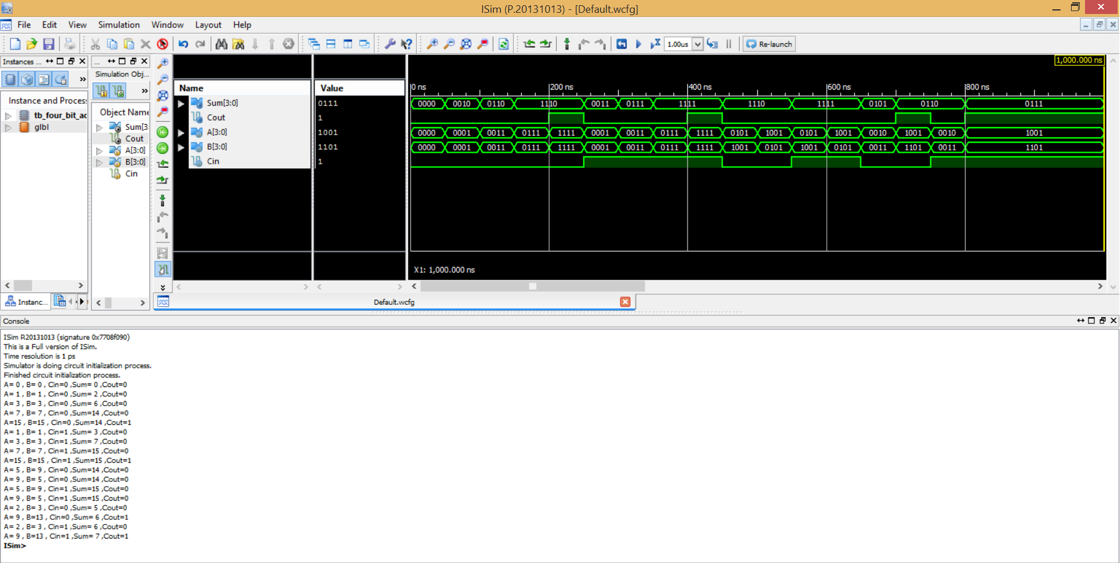

**4. Problem Solving**

First of all, I searched the internet to decide what to do.

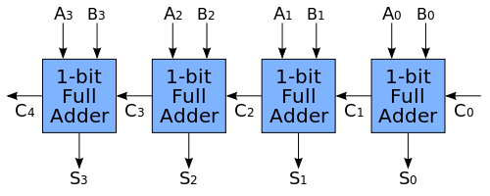

I found the picture above. I created a 1-bit full adder verilog module and encoded 1 bit full adder. I defined inputs and outputs for 1-bit full adder. Then I created a simple 4 bit adder modüle. I defined inputs and outputs for simple 4-bit adder. I called 1 bit full adder module from 4 bit adder module 4 times and I sent the inputs and outputs in the 4bit module to the 1bit full adder modüle. Each one's output(COUNT) is set to be the input(Cin) of the other. The last Count is the fifth step in dual-standing.